Meeting Minutes
Date: Monday, 10th April 2023 | Time: 6:30pm

Attendance | Nathan Clarke, Samantha Lambie, Lynn Stevenson, Jasmine White, Joshua Lloyd Jones, Troy Bates, Larissa Sewell, Phillip Bates, Rebecca Austin, Gwyn Williams,
Apologies | Max Sutherland,
Business Arising from Previous Minutes -
- Typo in Friday nights usage, Should read “an option”

Previous Minutes Accepted -
- Jasmine accepted, Sam Seconded
President’s Report
- The Trial day with Kotara went very well, 1 O35s team didn’t turn up on Friday night but other than that, the feedback received by the majority is that it was a great weekend. Thank you to all the volunteers who assisted throughout the weekend.
- There was an incident on the day in the morning where a baseball hit one of our parents, the ball escaped the batting tunnell, Council is looking at this due to the condition of the batting tunnell
- ZFL due to commence this weekend, there are a couple of trial games on Saturday and Sunday for the season to commence for the rest of the club on 20-22nd April.
- Parents who wish to do a final collection of their socks and shorts prior to the season start can do so this Saturday from 9-11a.
- The Coffee Making training is also occurring 9am this Saturday, Larissa arranged this on behalf of the club.
- The club is in need of more volunteers, the main priority will be gameday volunteers to assist at just being a presence at the ground, assisting our members and other teams on where games are and being available if an incident occurs so there is a point of contact at the ground for the club. If you can assist, please email the club email address. It is quite a simple role that the more volunteers we do get, the less everyone needs to do
- Secretary is now of urgent need. Under the clubs constitution we should not be functioning as a club without a secretary. While we are doing what we can with other volunteers chipping in to help, it is now imperative we fill this role. It may be to the point where the club may have to fold if this critical position is not filled.
- We would expect draft designs for next years strip for the next meeting, With the arranging of the trial day, and the volume of work during the registrations, I have not yet pushed this, will be a priority for the next month.
Secretary’s Report –
Correspondence Out 360+
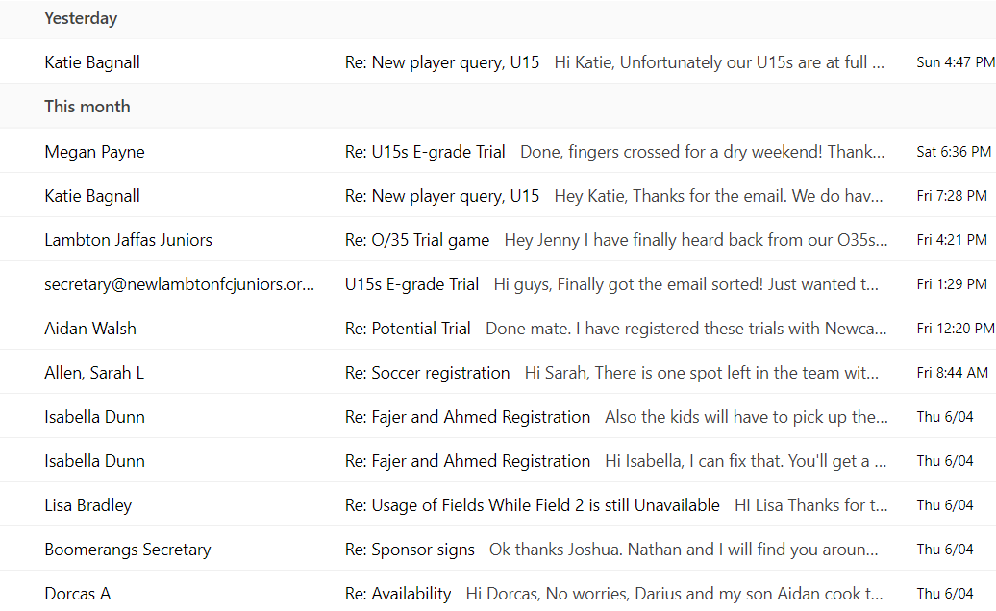
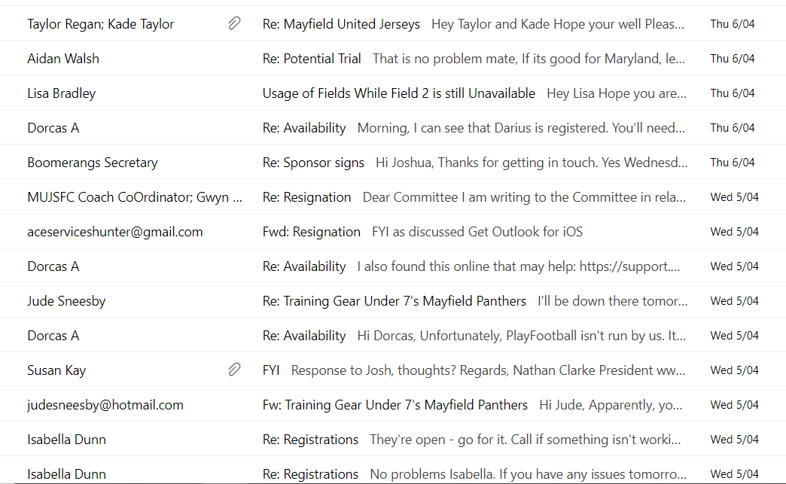
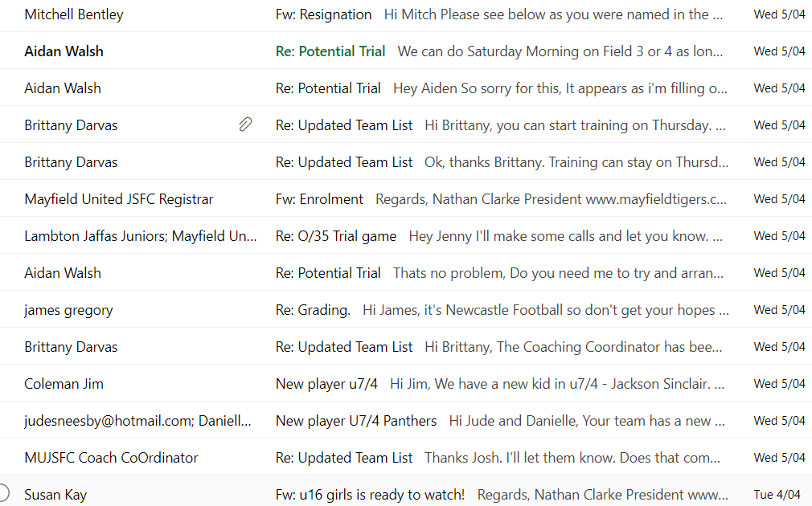
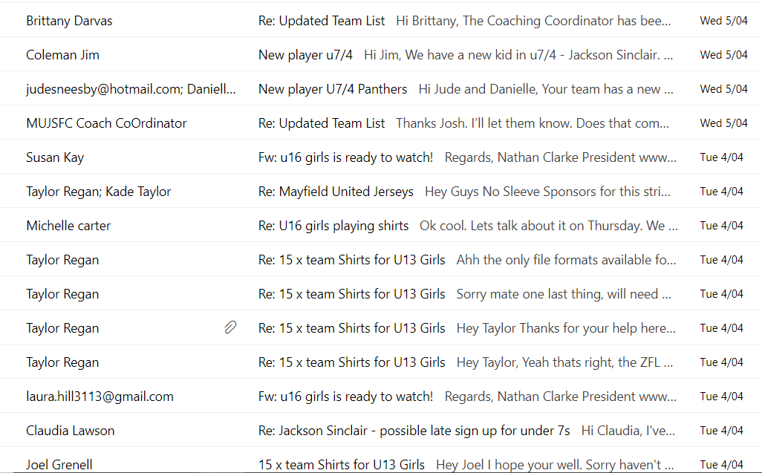
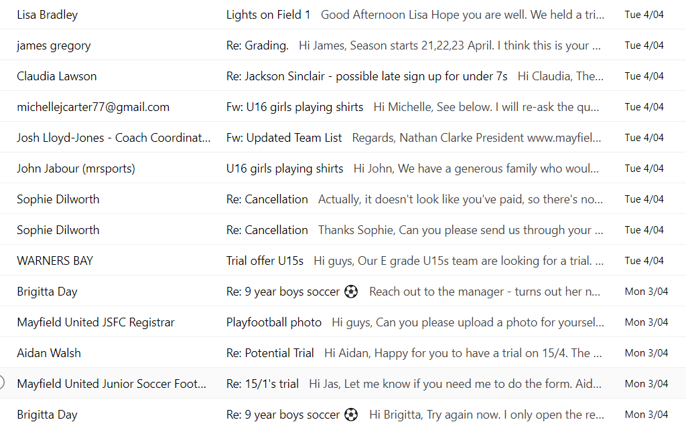
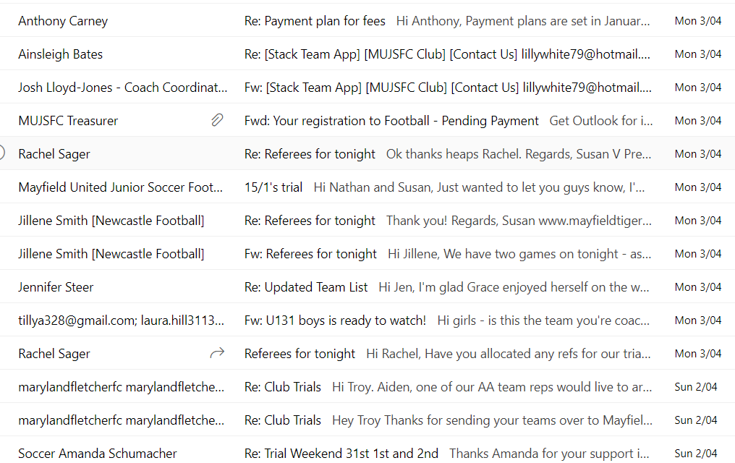
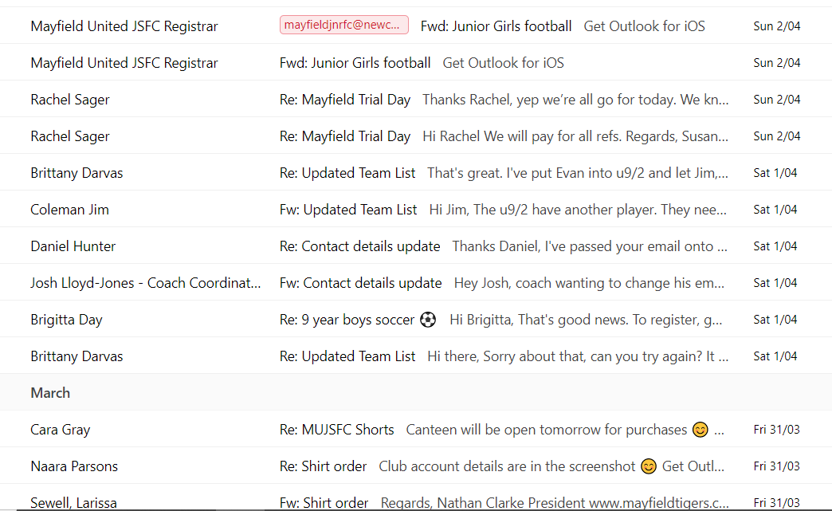
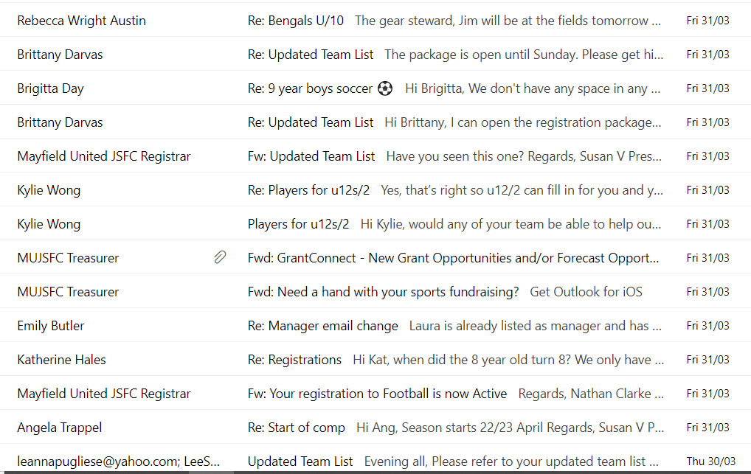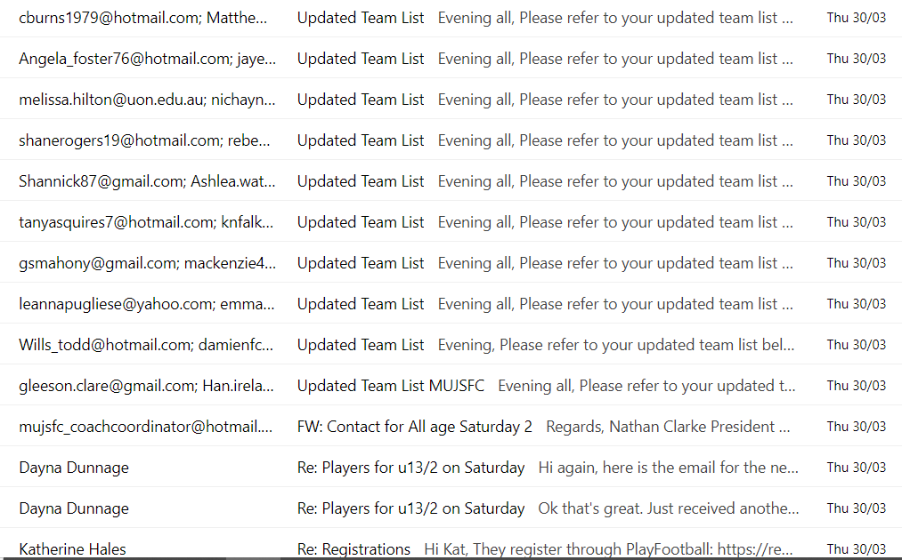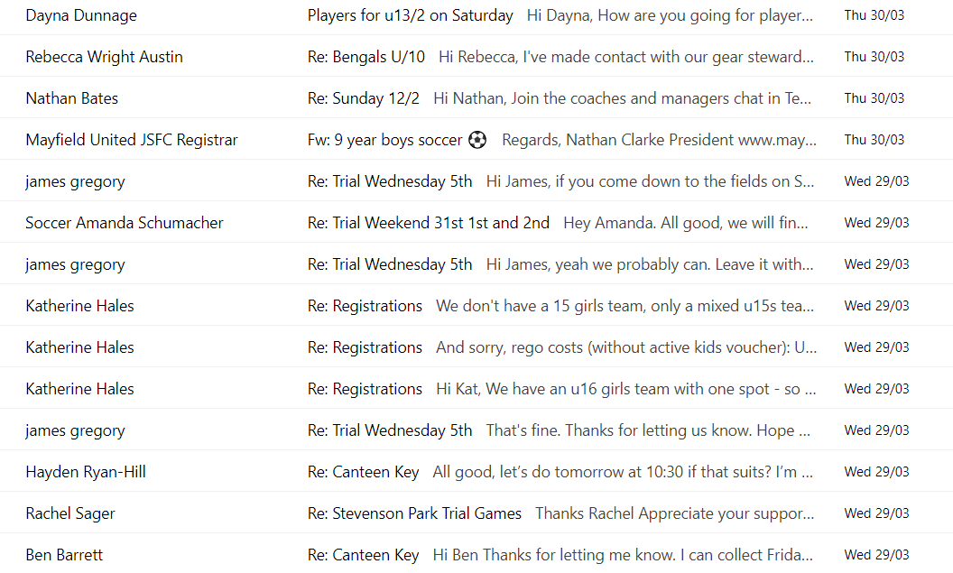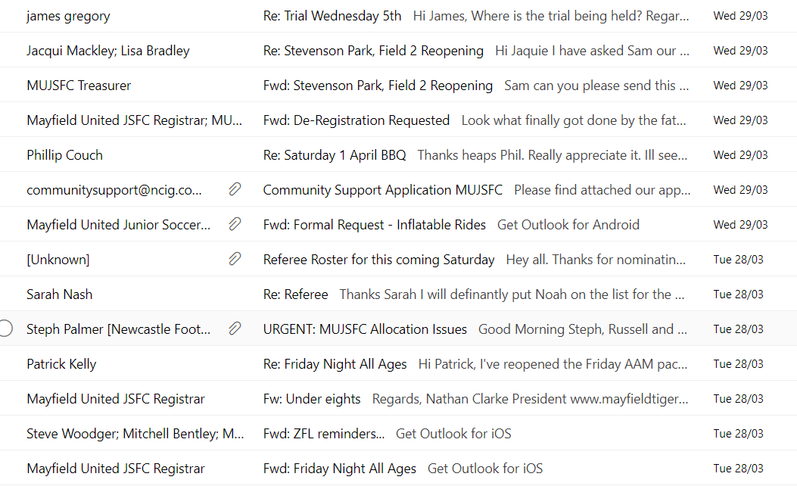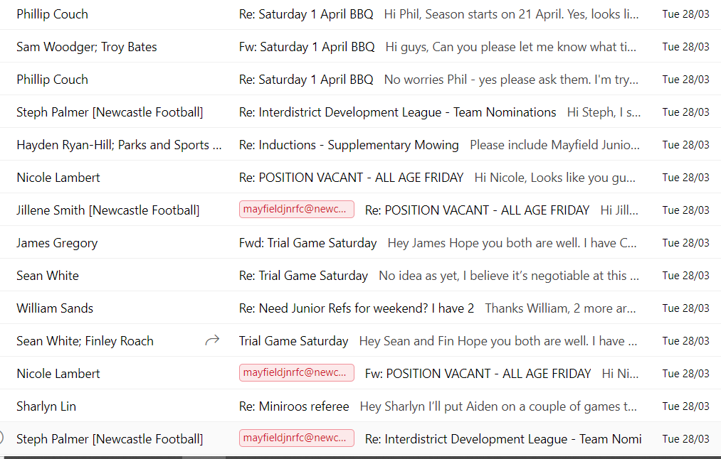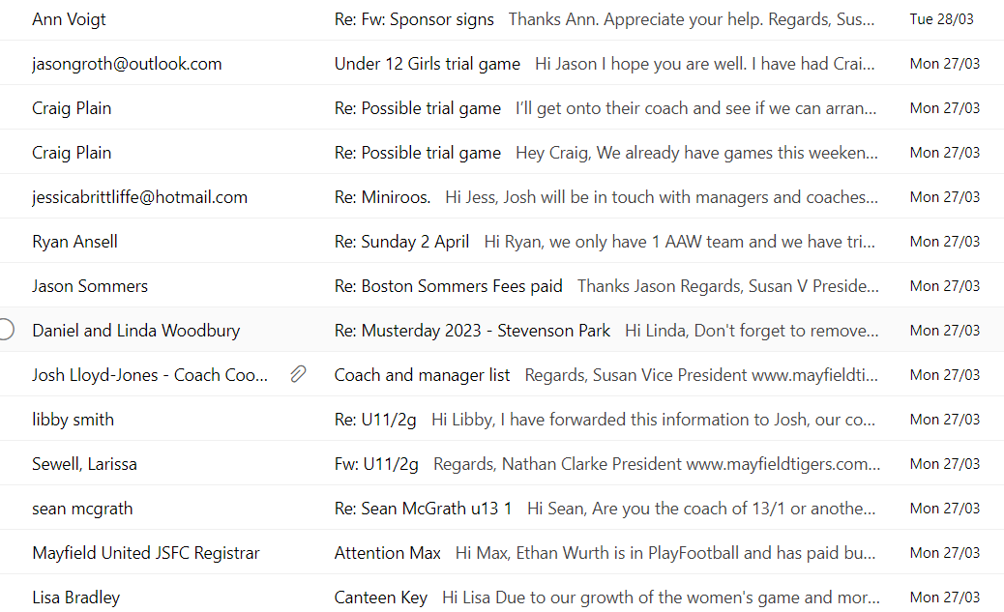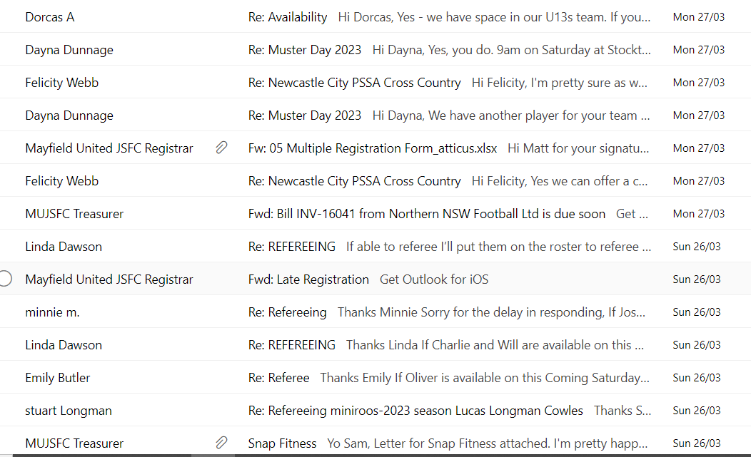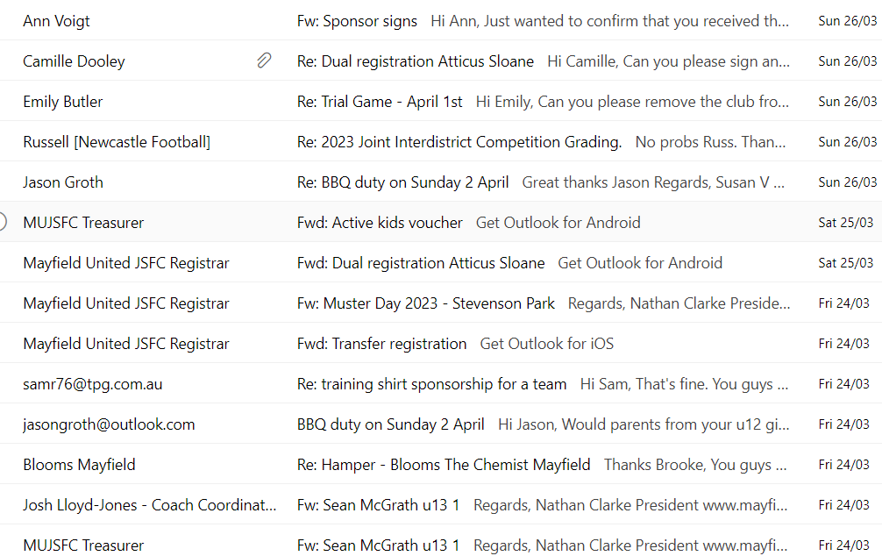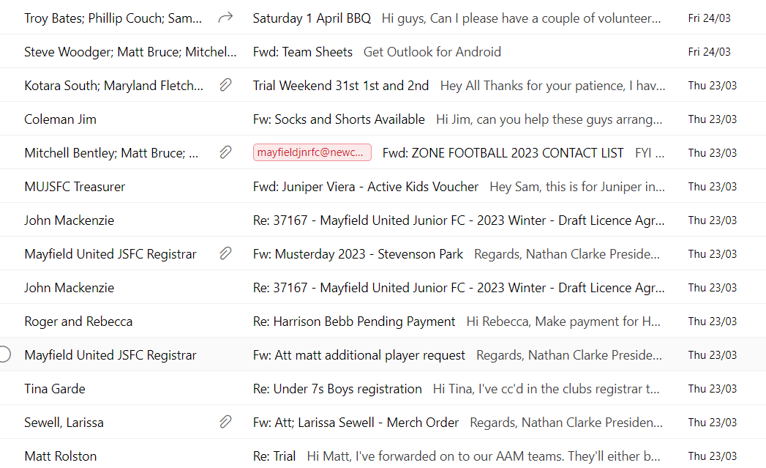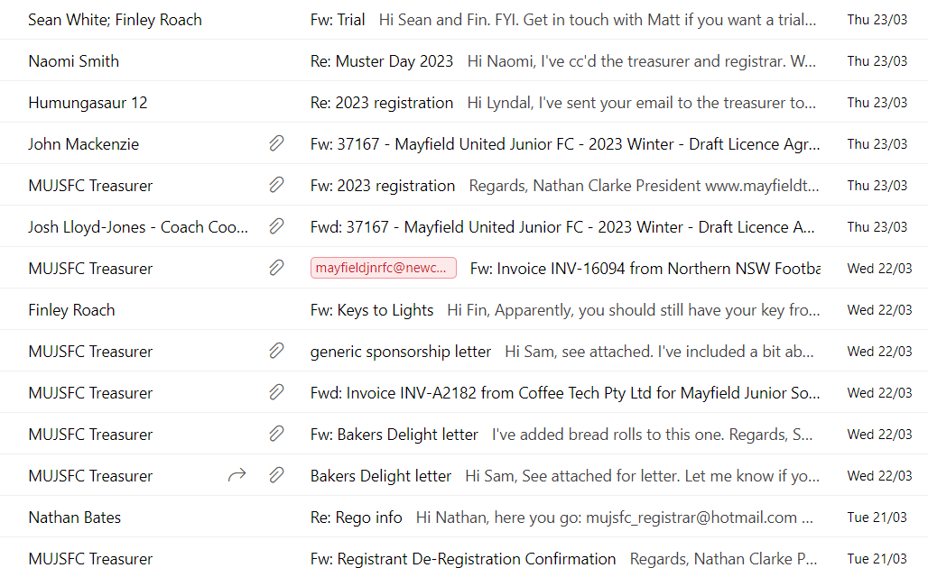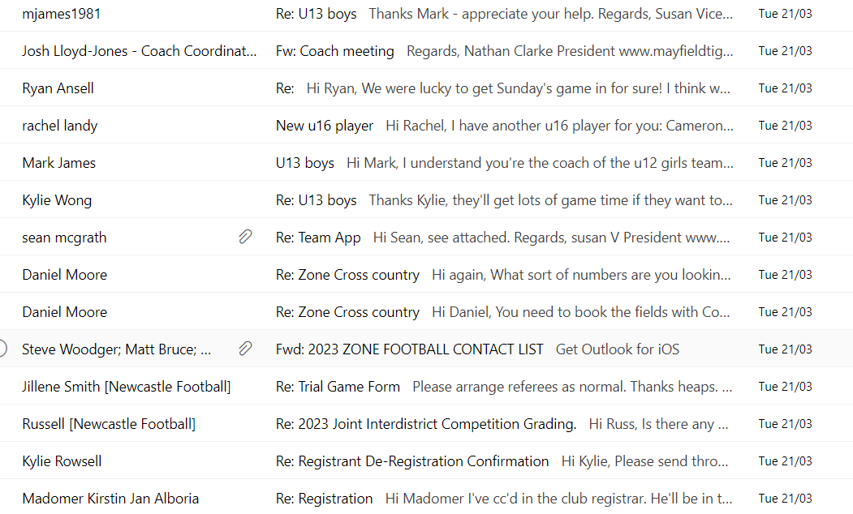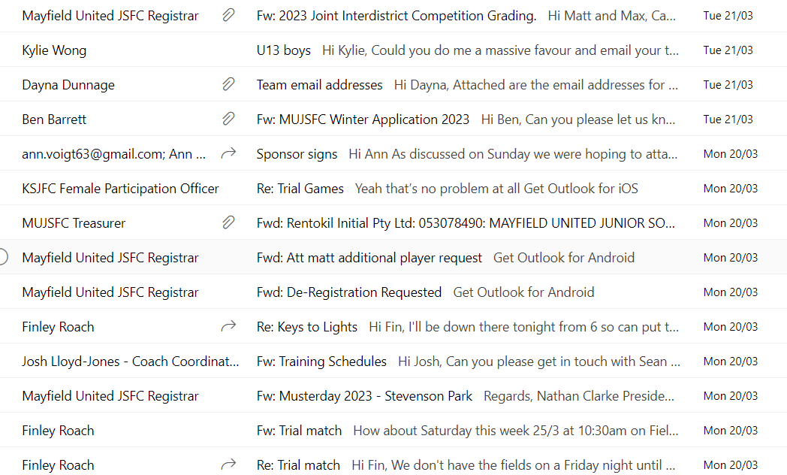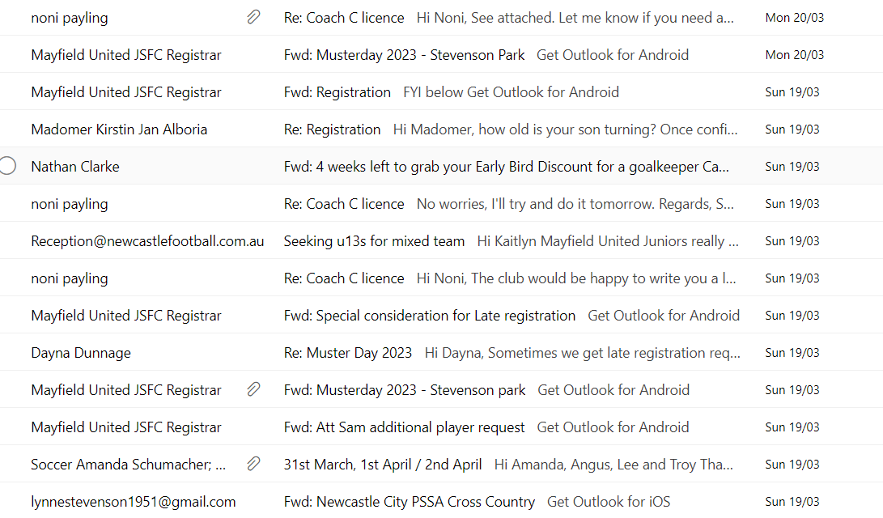
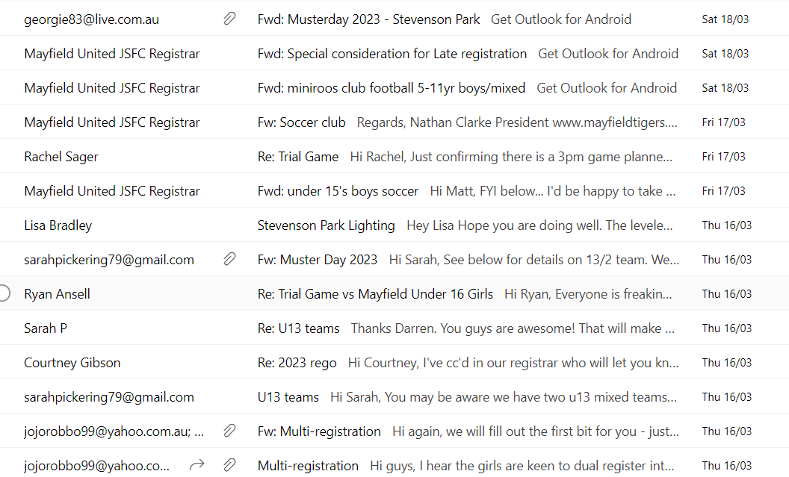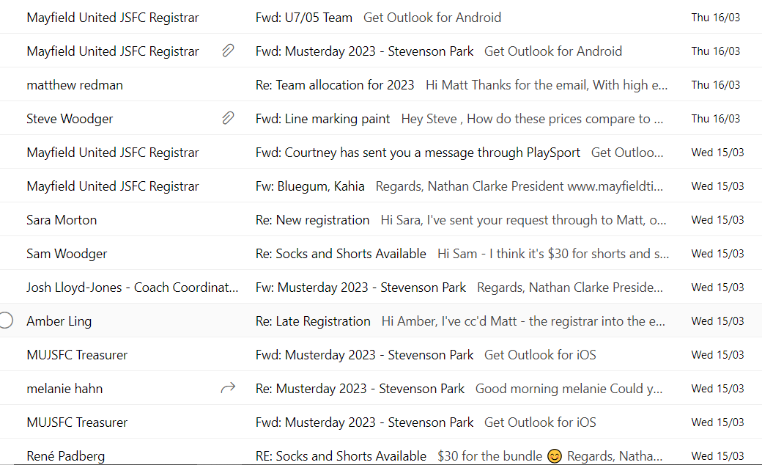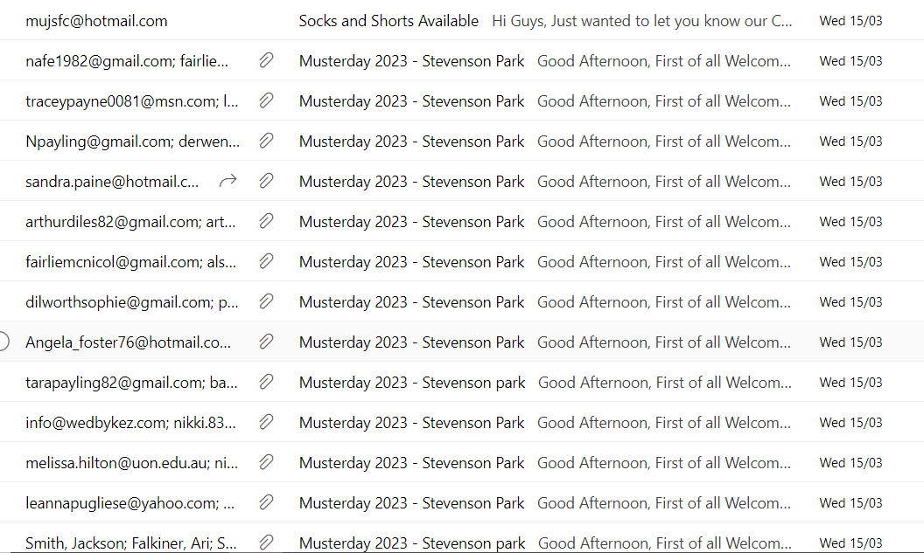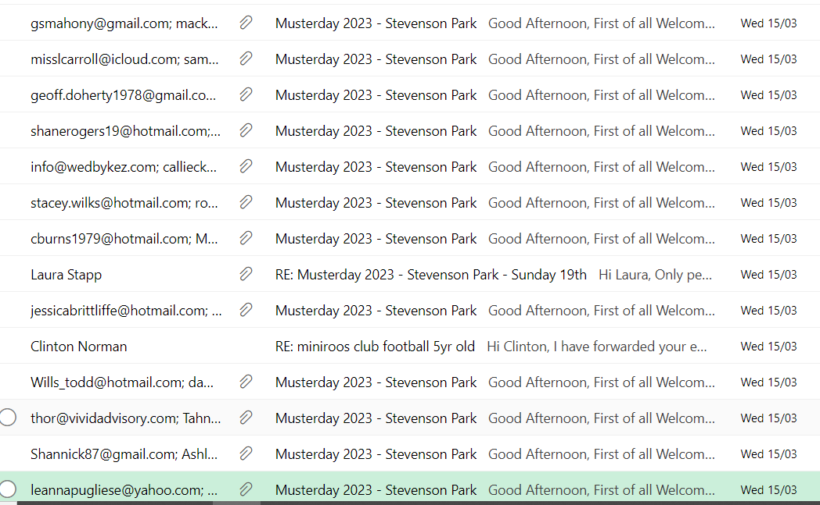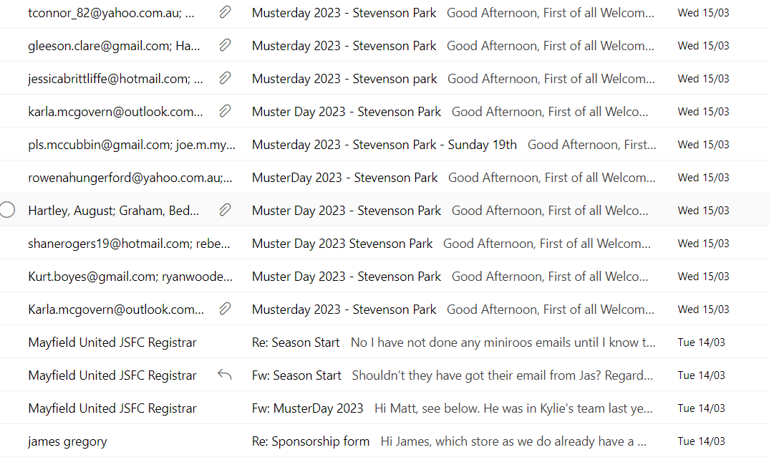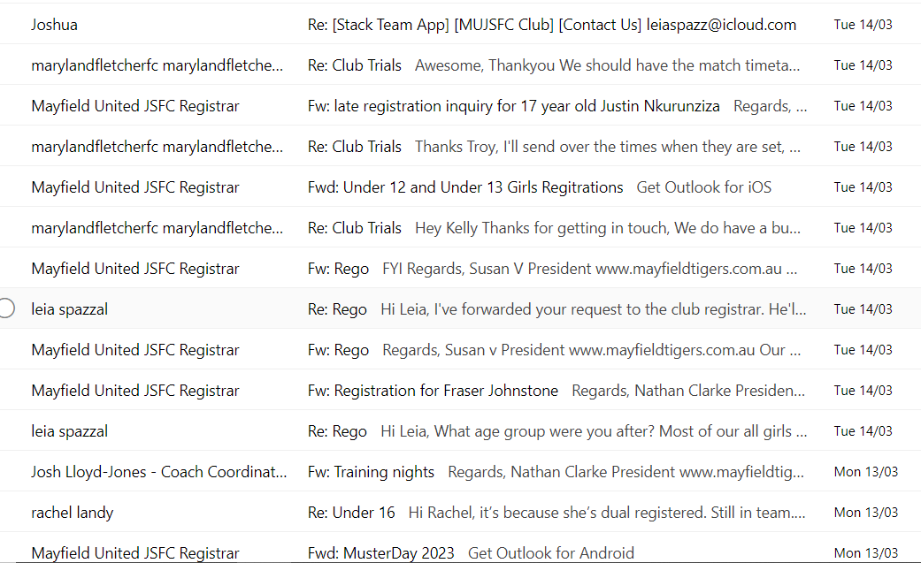

Correspondence In – 530+
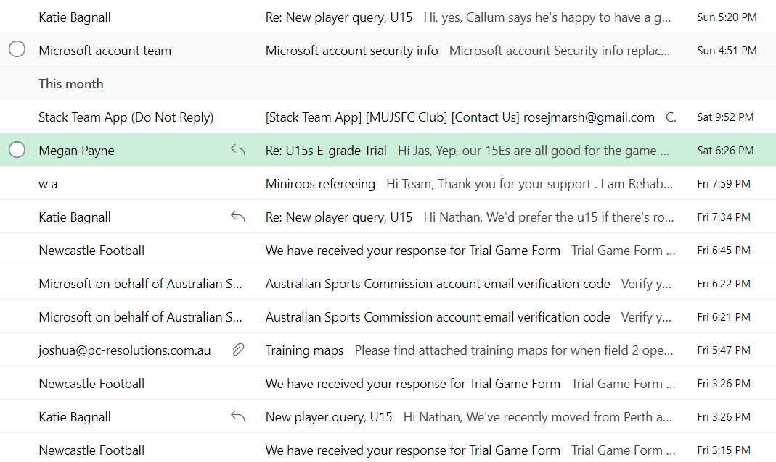
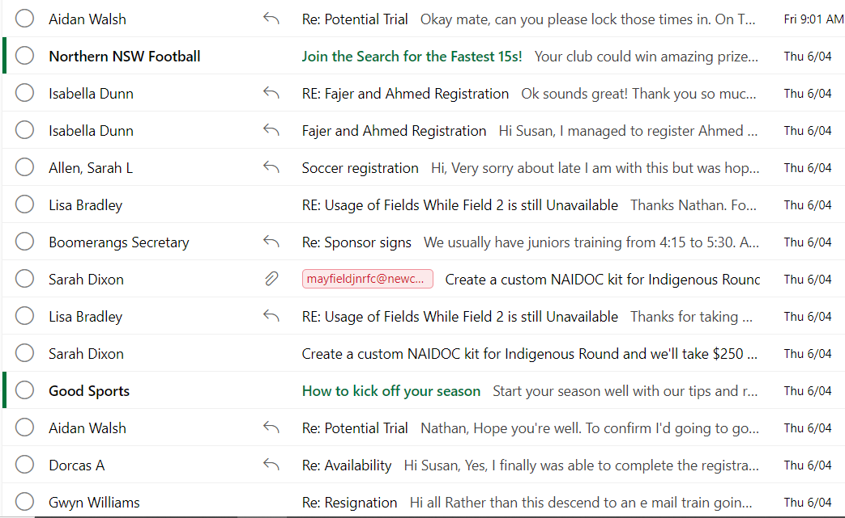
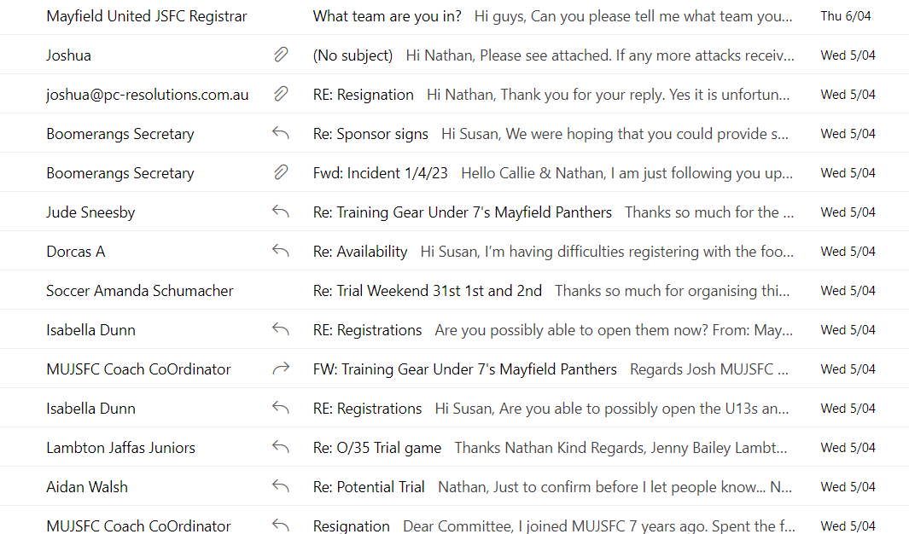
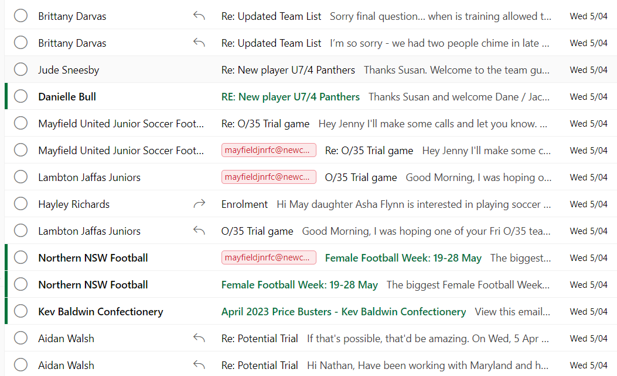
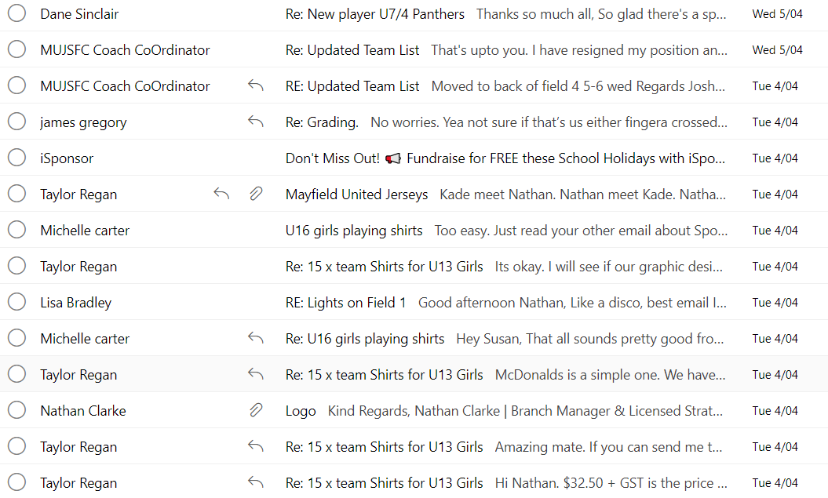
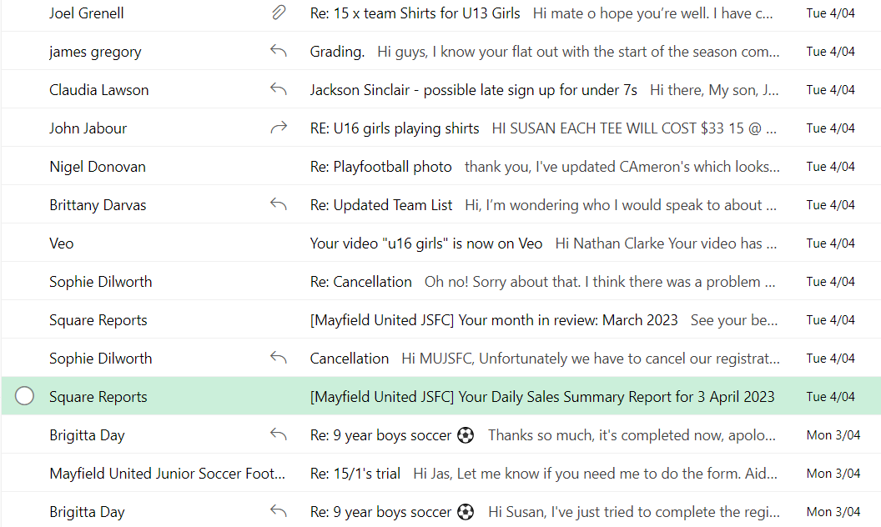
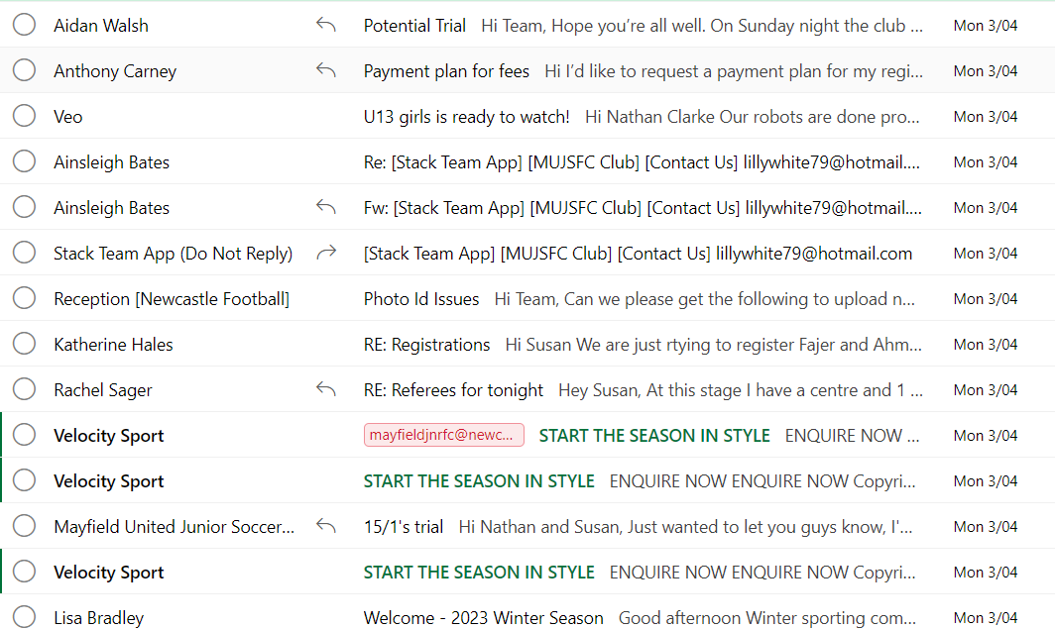
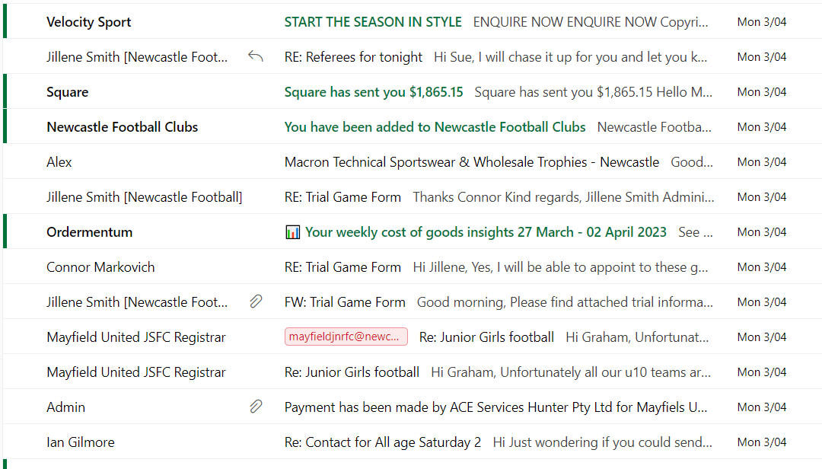
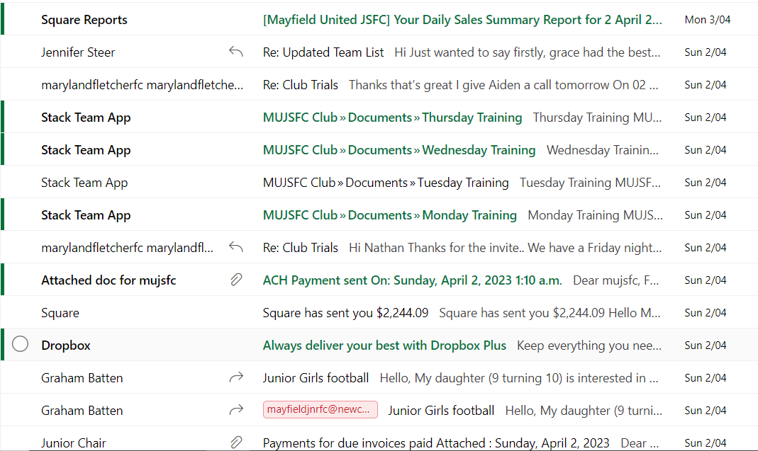
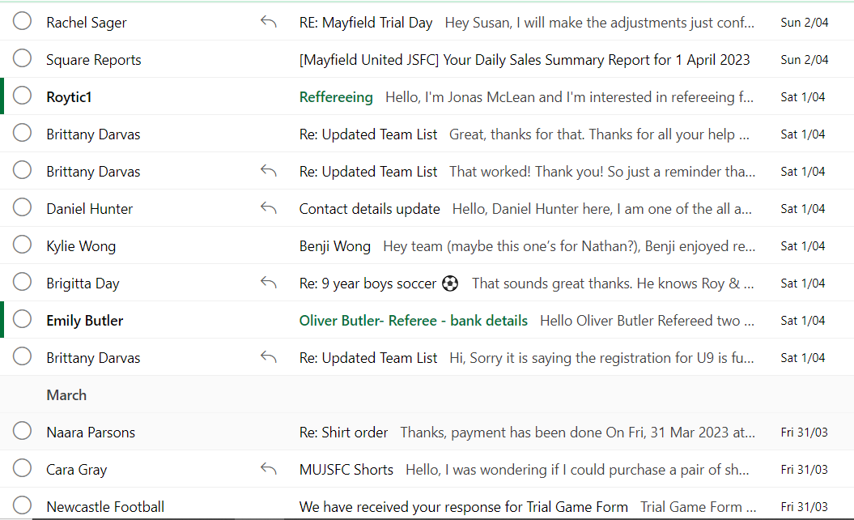
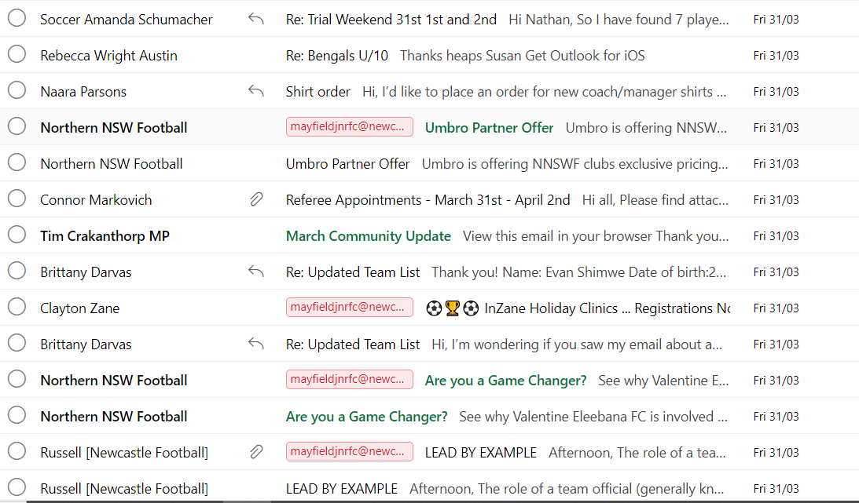
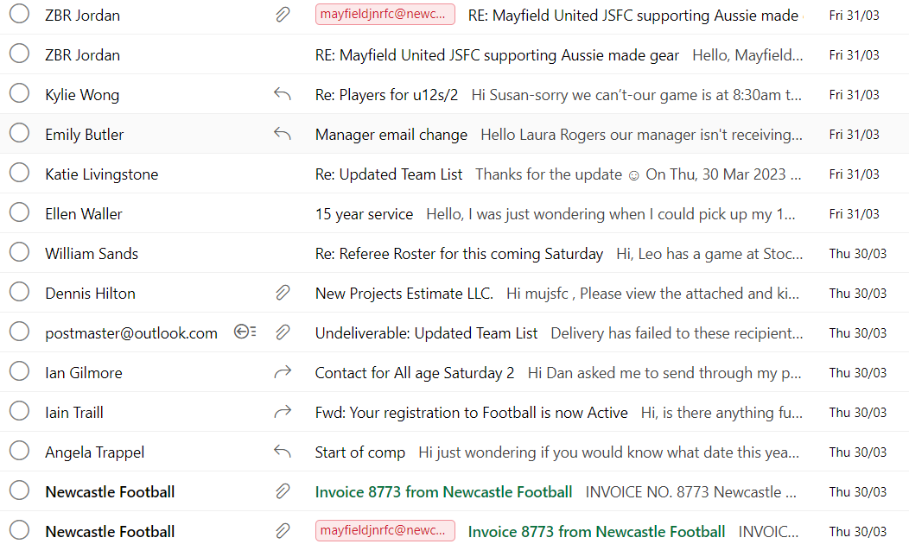
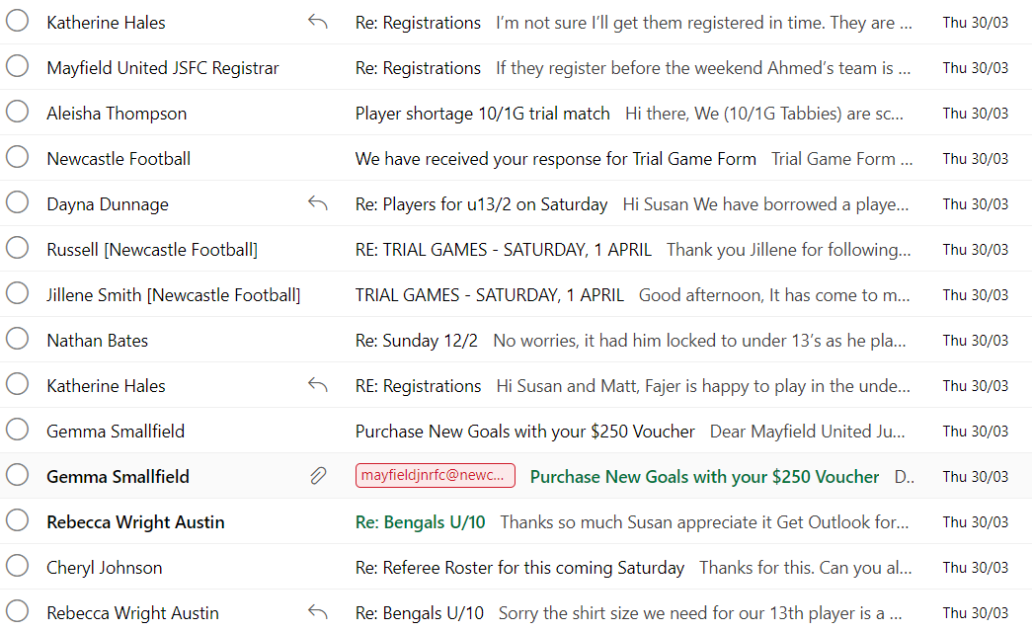
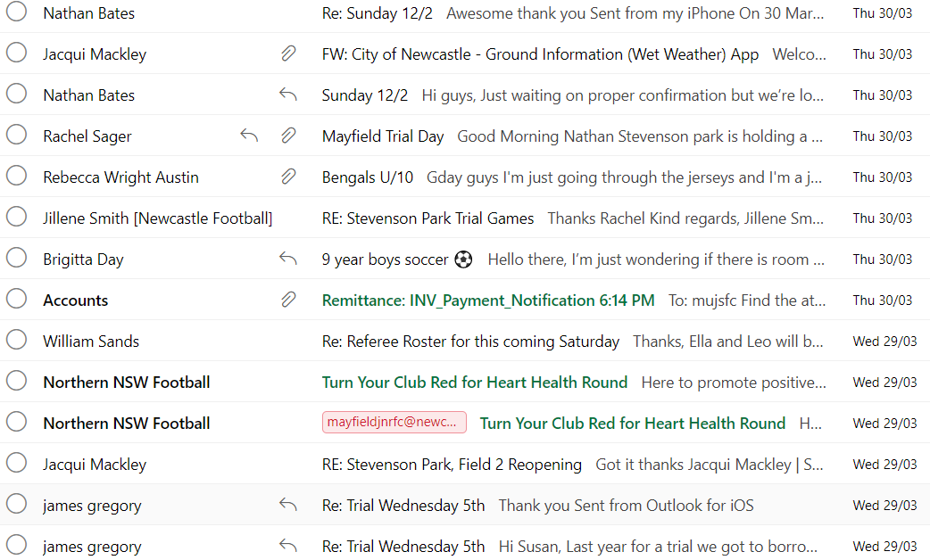
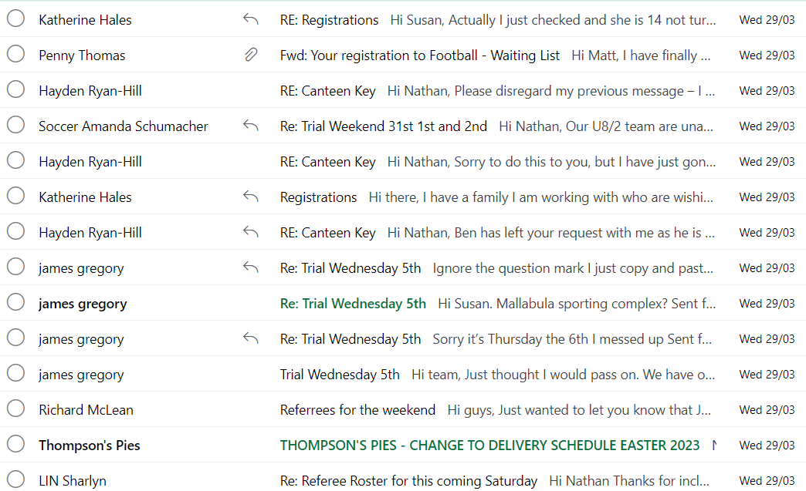
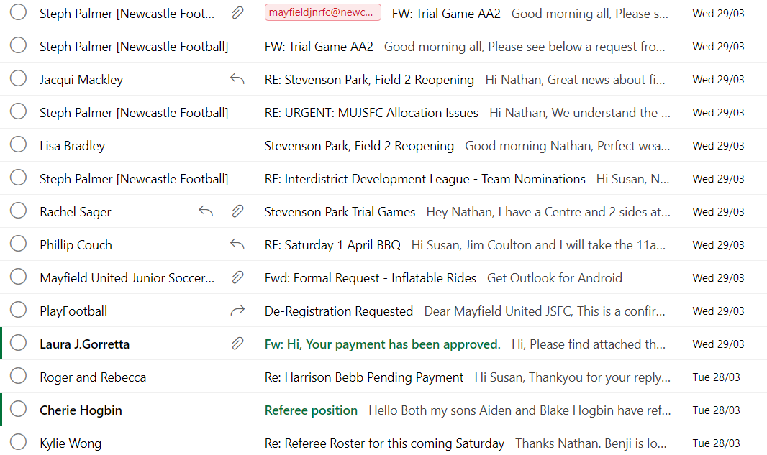
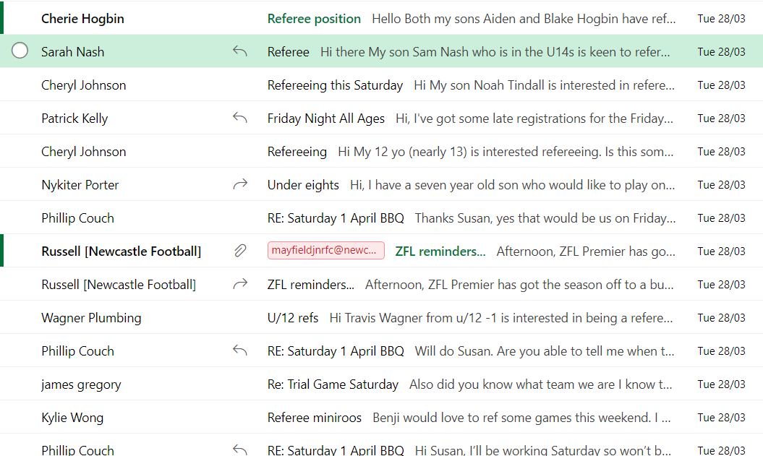
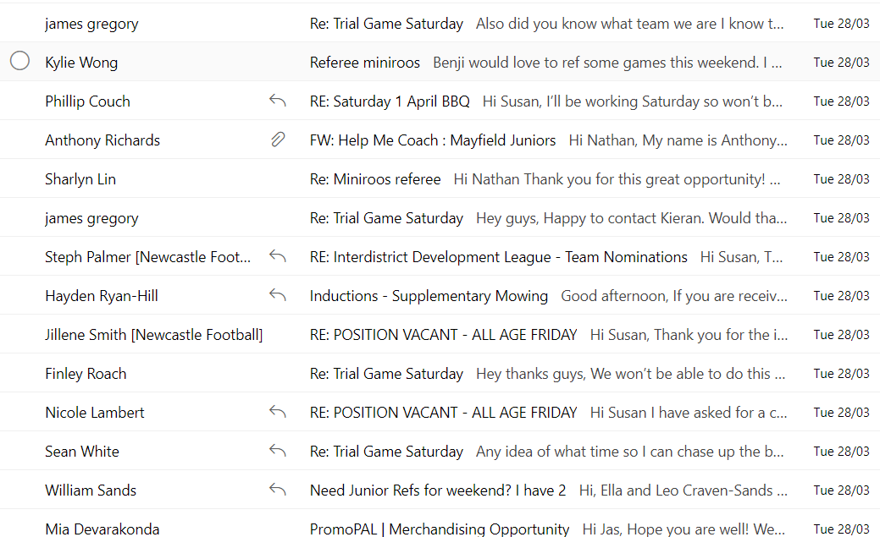
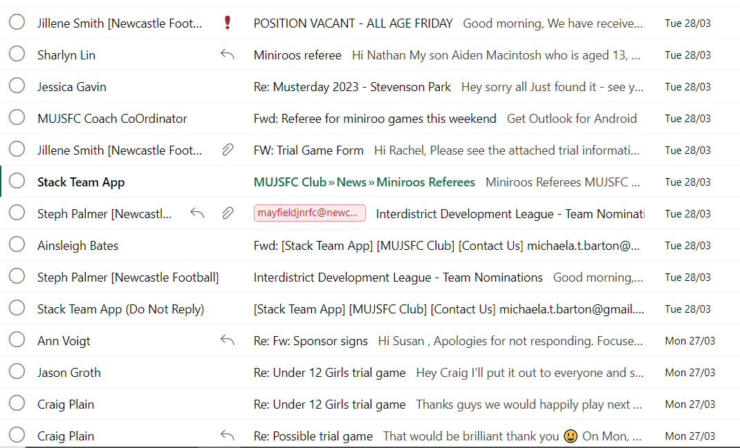
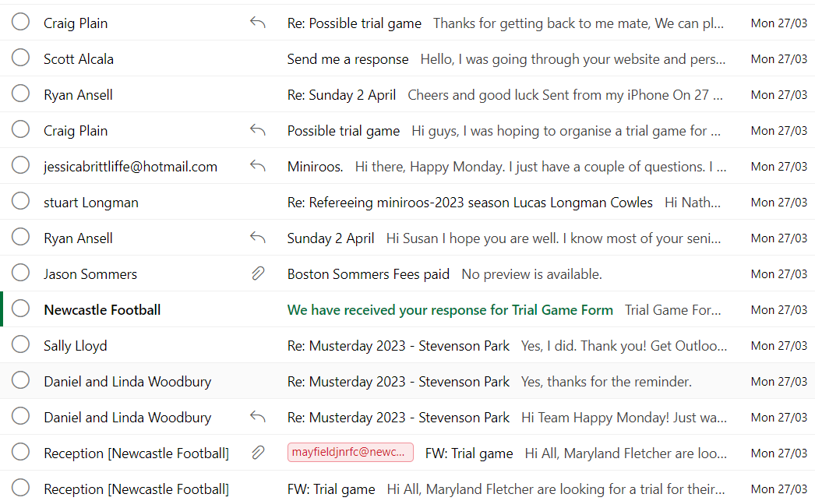
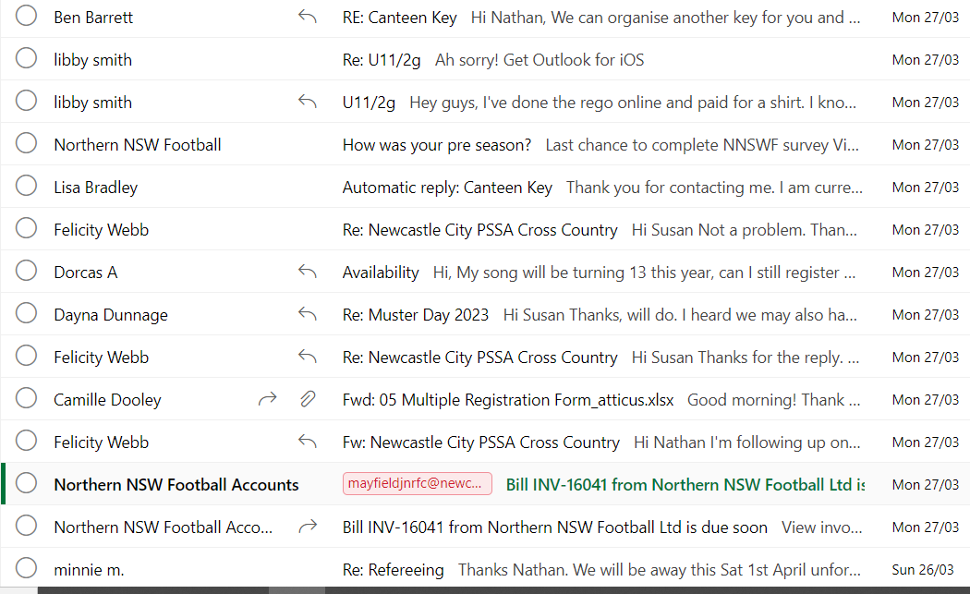
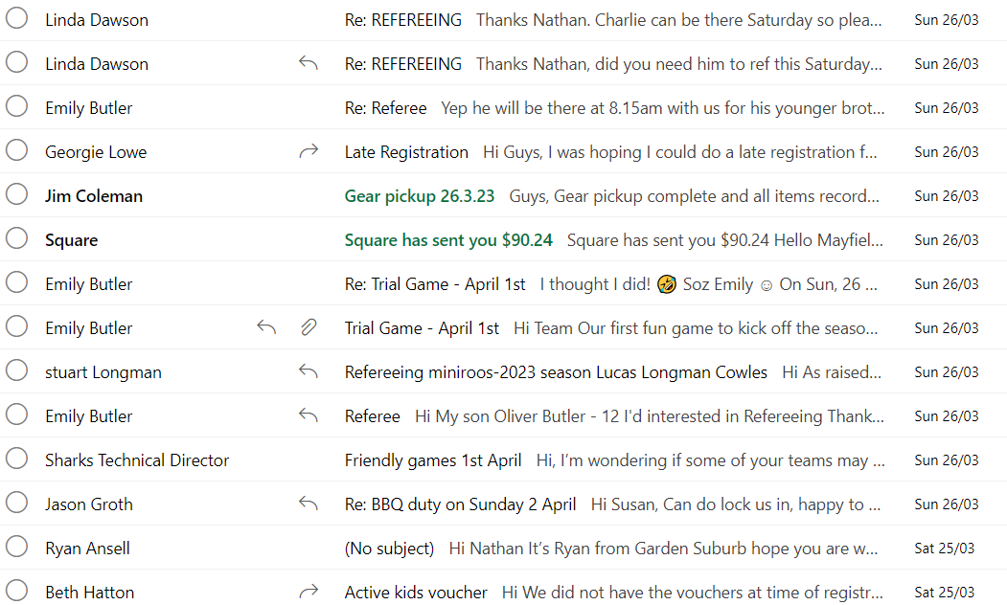
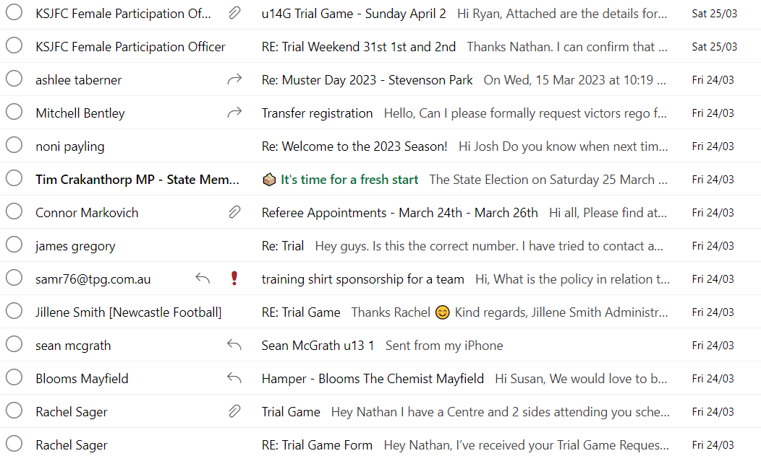
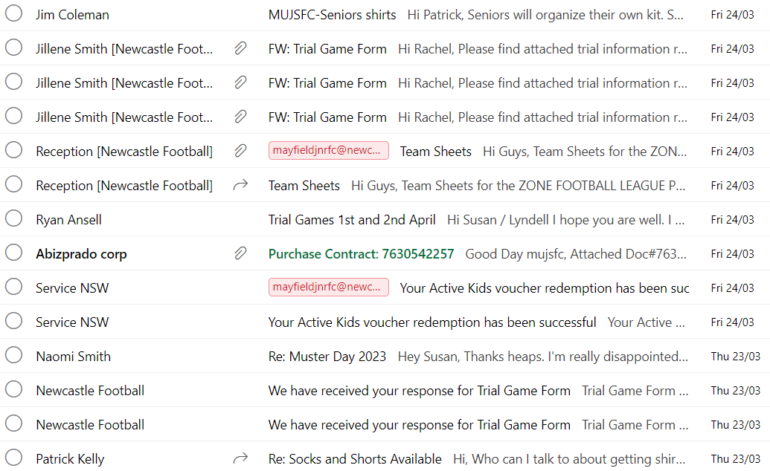
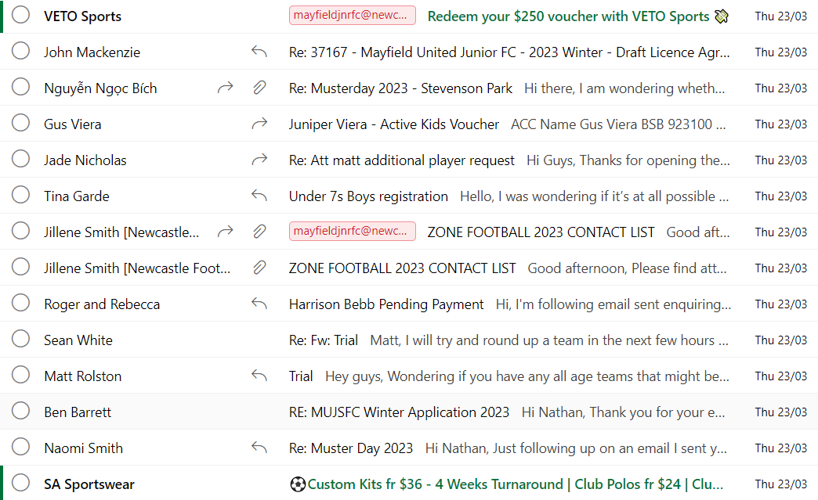
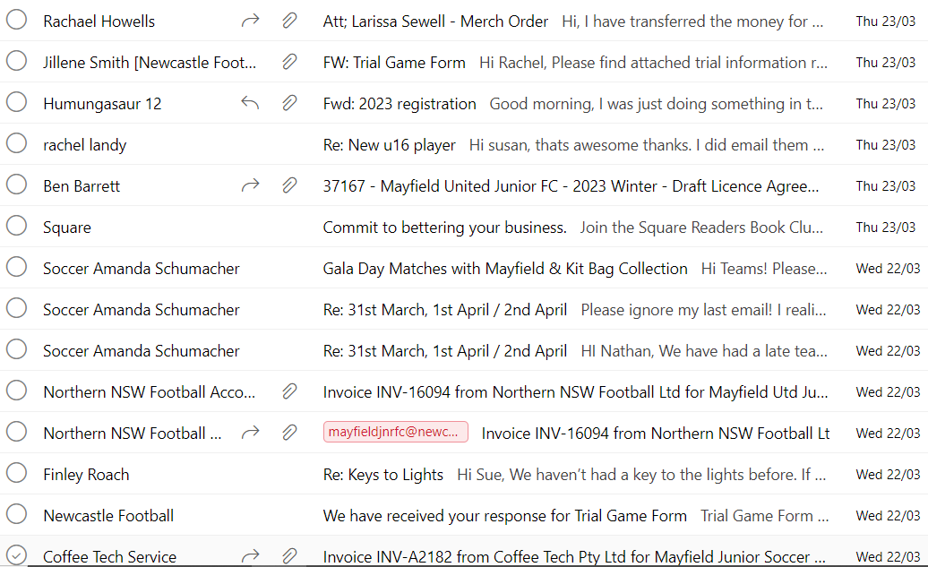
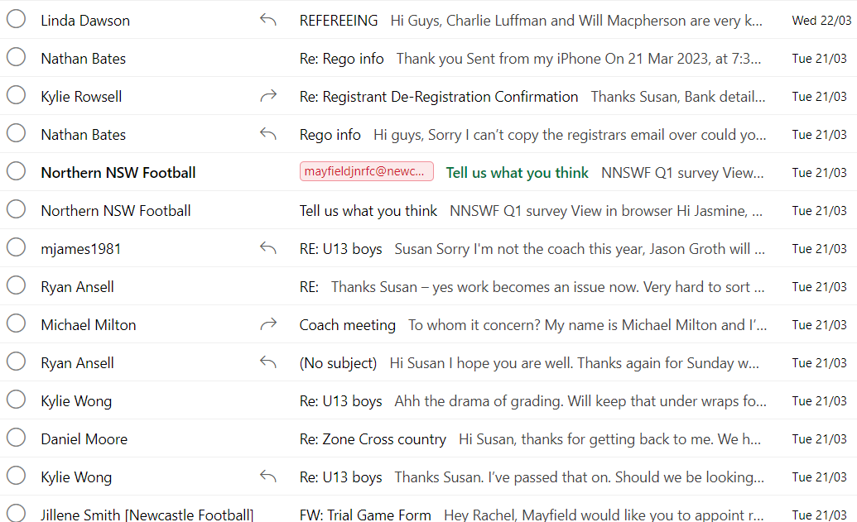
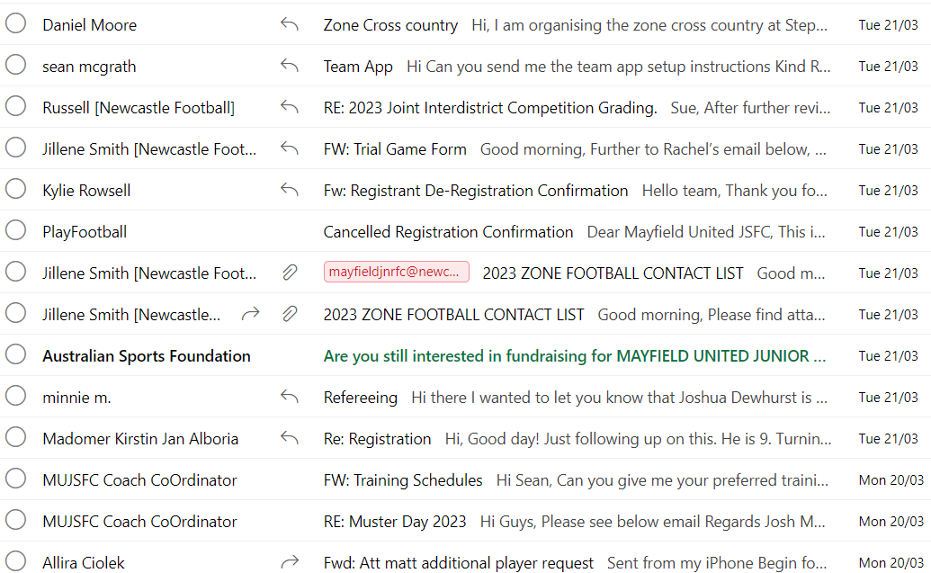
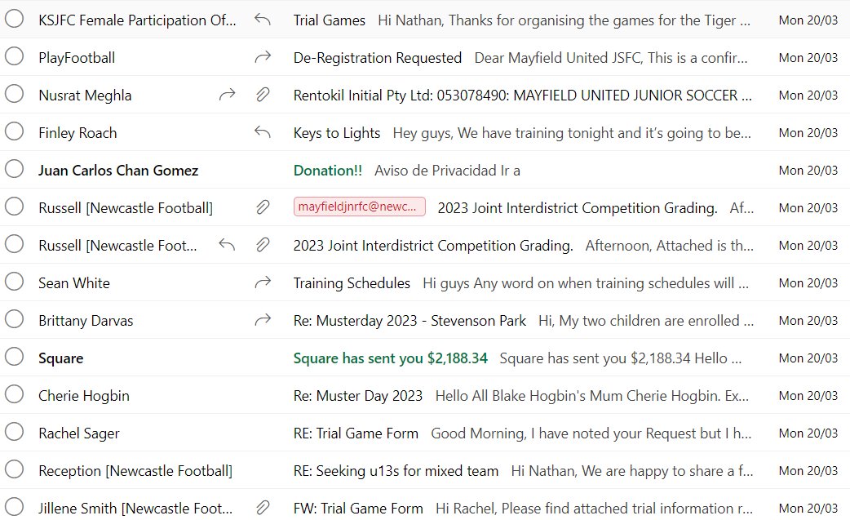
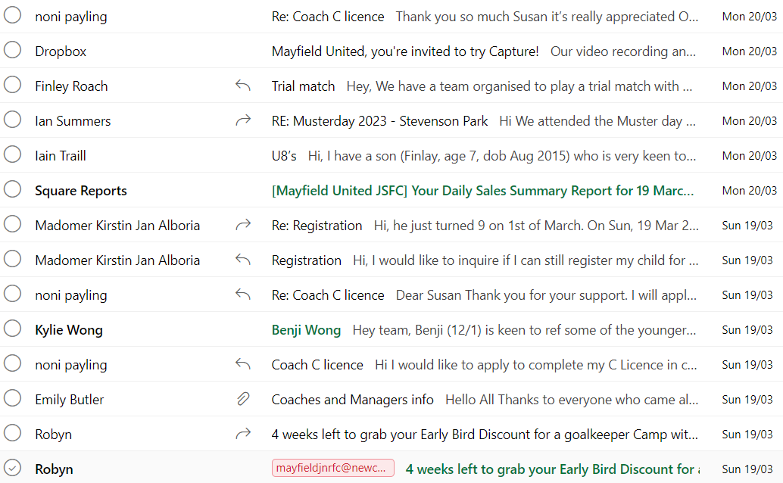
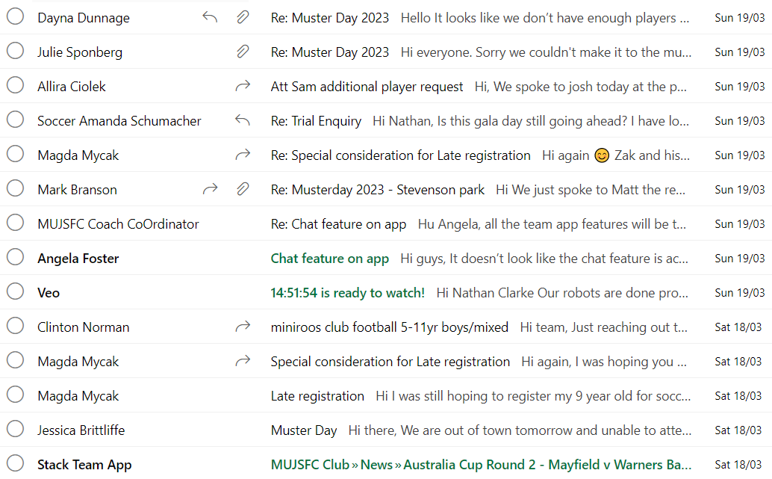
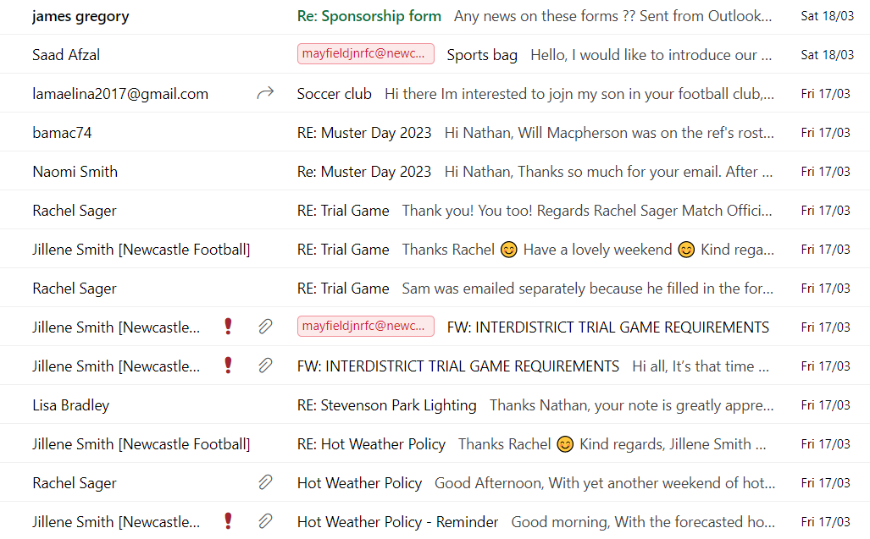
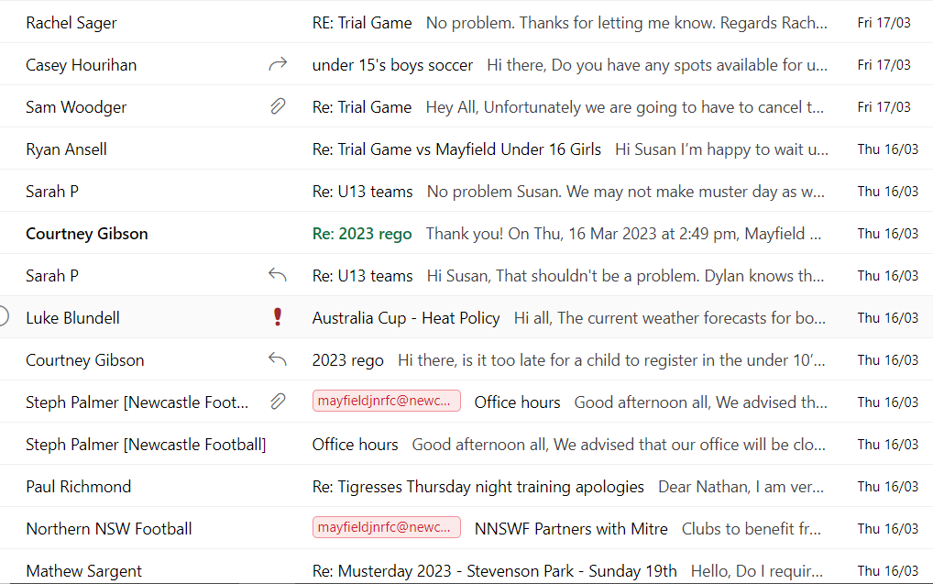
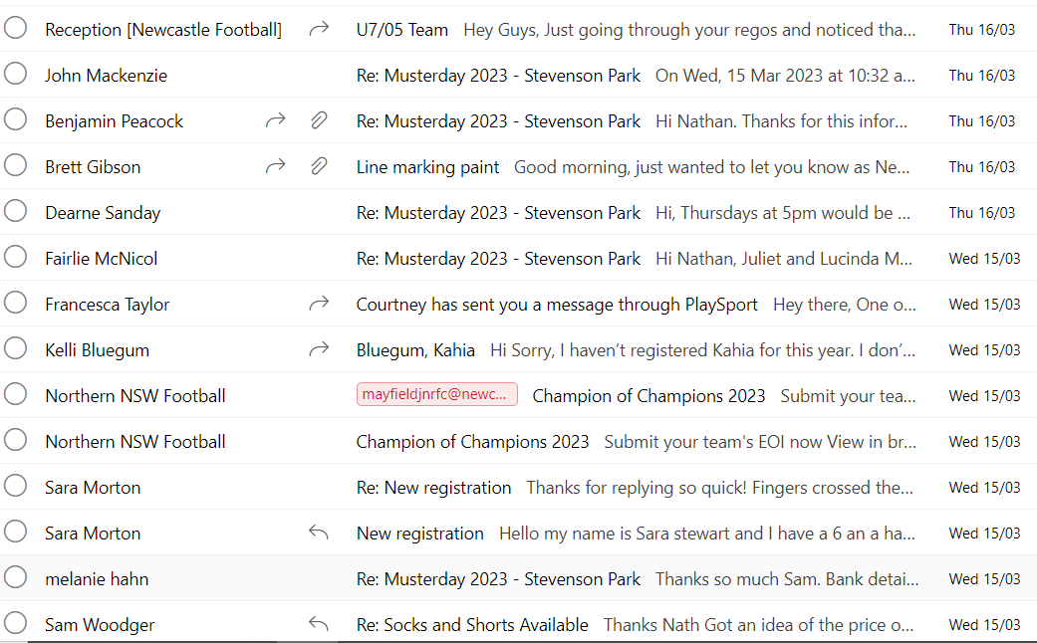
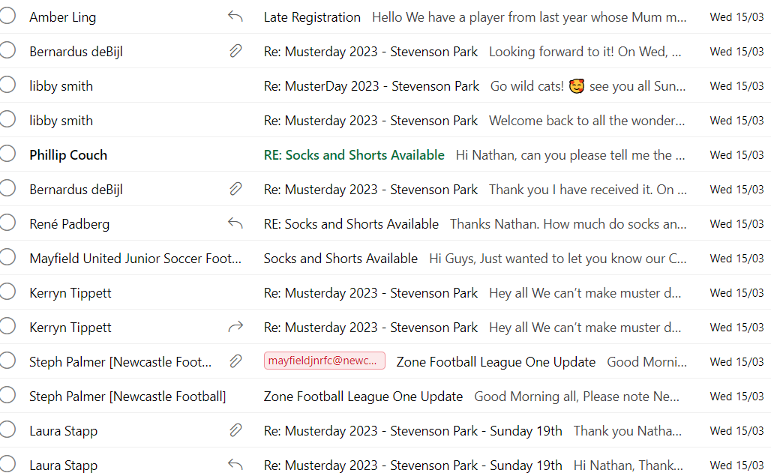
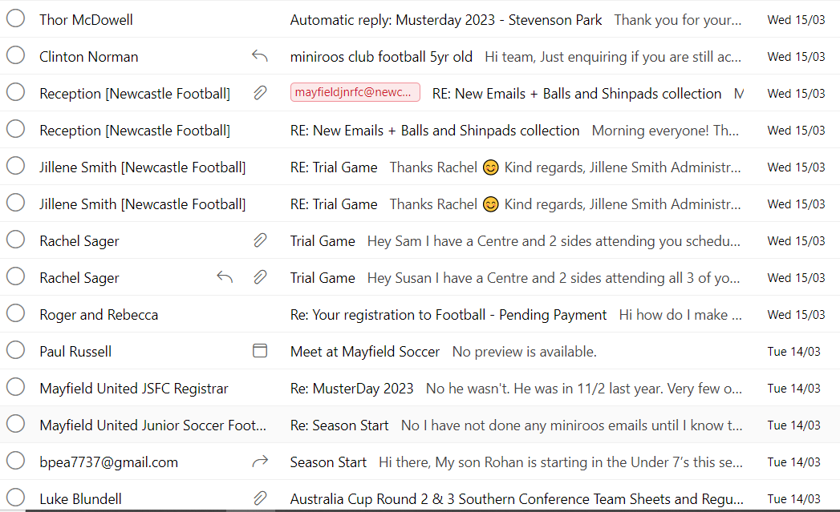
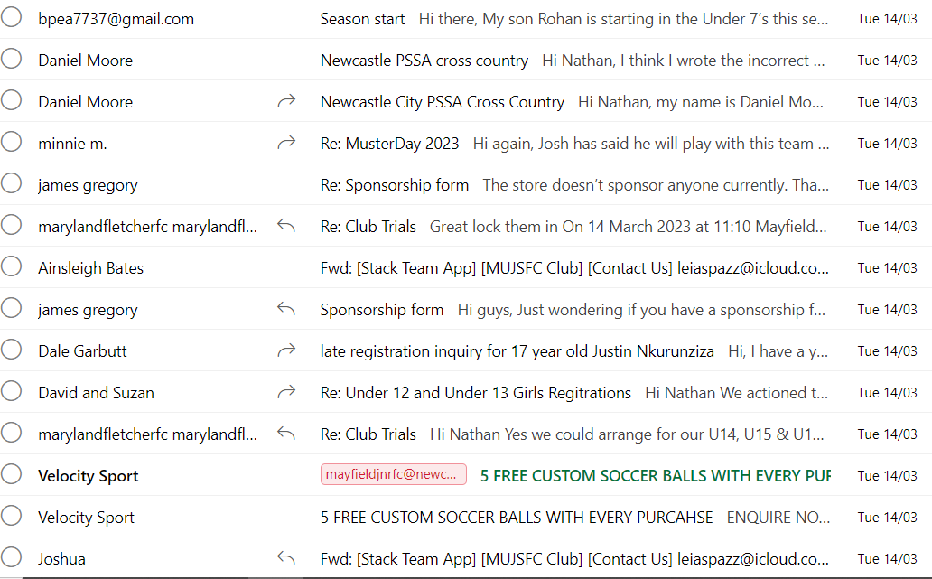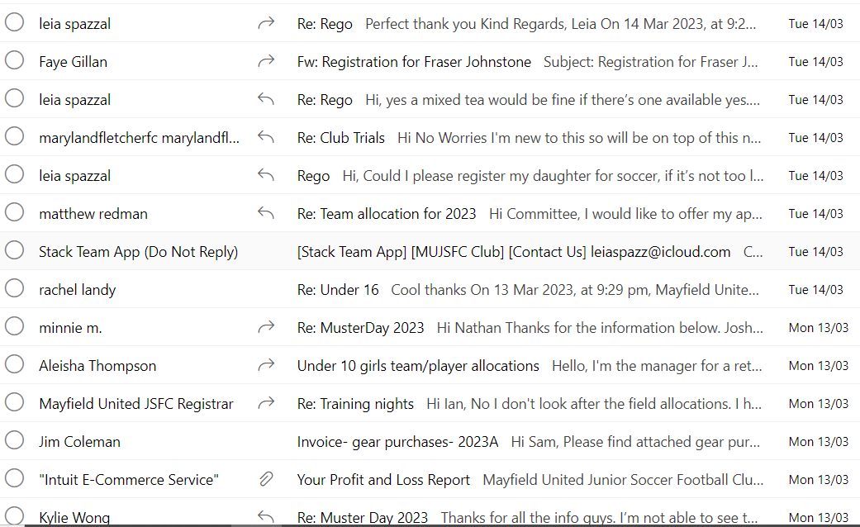

LaSMINE MOVED AND jOSH sECONDED
Treasurer’s Report -
As Attached Bank Balance-
218810.42
Gear Steward Report – N/A

Registrars’ Report –
- 154 seniors
- 134 junior comp
- 388 miniroos
- Need players for under 13s
Coach Coordinator Report –
  - Coaching Co-ordinator has resigned from his position, If this position is of interest to you, please contact the club if you can assist.
Canteen Supervisor Report –
-Cross Country 28/4/23- no chips as too many people.
-Commencment date for schools- no date
- Collection of gear- to busy with people buying food and gear at the same time, need to organise a better system.
Coffee training – tafe are running the day. Donating the coffeebeans and are donating a grinder

Association Report – N/A

General Business –
- St George to be added to website until 2025
- Accrediation – female participation officer
- Club name change- no officially proposal as yet. Only discussed no need to bring to a meeting.
- Merchandise orders placed last wednesday. All coach and managers shirts ordered, backpacks ordered $30 per back pack.To look into dog coats again. White shirts are popular, small shorts have been ordered.
- Facebook post regarding gear collection on the 15/4/23.
- Draws should be coming out in the next week. Laura will be ding up the game day sheets.
- Team sheets are available.
- All age mens friday night team will be changing their socks to yellow August and Sept for prostate awareness.
- Trophy Shop – need a new medal supplier, need list by June/July to organise.
- Volunteer roster- need to organise a roster for the season for volunteers to cover game days. Also BBQ Roster needs to be organised.
- Trial Game 15/4/23 - Jim needs to attend. Table to be set up. For collection of gear.
- Baseball meeting – to get sponsorship signs put one behind field 1
- Grant- For goals. 2 sets of rolling goals.
- 5th May- Bill back to council- to bring back down costs. Refunds from summer and winter.
- Sponsor days- As a club. Combine with ZFL.Matt to organise
- ZFL – rope of spectator line. Due to game against Crotia.
- Quote for pop up signs for ZFL- Pop up banners. To be put up and taken down after game.
- Corner flags- replace and put sponsors on the flags on game days, cant have sponsors on corner flags.
- Veo- need to put a notice up that it is being recorded. For safety reasons no sound.
- Team App- we can pay to remove the ads and add our own sponsors.
- Communication Officer- to post on social media with sponsors, game draws and results.
- Trial game- Mayfield boomerangs has th eliquor licence for stevenson park, cant bring alcholol to the field need to purchase from the boomerangs. No glass bottles at the oval.
- Softball- need to repair their pitching bound. Send a email to council regarding the repairs, should be done by the ¼/23 .
- Field 2- needs to be top soiled, to contact council regarding the field.
- Need to look at better lighting for field2, and all grounds will allow the end of the field to be used.
- Training – no space on a Wednesday, no access on field ¾/. Need another field in Mayfield have been offered fields in different suburbs.
- Training possibly to offered on a Sunday.
- Trial Game- regarding possible suspension on under14 Jye regarding actions and comments to the ref.
- Larissa to organise unisex signs for changerooms.
- Need to obtain Field Closed signs.
- Josh email- resigned position as coach and coordiantor . Email hasb een sent some issues have been addresed but not all. Zone getting a lot of the attention and the 6-16s are getting no attention on facebook.
- N- zone have been playing but the mini roos havent. ZFL are the future and givesd the kids an opportunity to progress further in the club.
- Not balanced with all the teams in the club. Zone are getting more attention and the 6-16 arent getting anything.

Close of Meeting: 7.12pm

Signed as a true and accurate recording of the minutes for this month’s meeting:

